Breast Cancer

Vital statistics…
- 21 000 deaths/year
  - prevalence of 100 000
- lifetime risk 1:12
- improving prognosis
  - improved treatments: Tamoxifen, new Oestrogen receptor antagonists, more breast conservation (cf mastectomy)
  - earlier detection
    - awareness
    - self-examination
    - screening
  - 70% 5 year survival for cancer confined to breast +/- nodes (1980s)

Breast screening was shown to reduce mortality by 25-30% over 10 years in five Swedish RCTs but see below…

NHS Breast Screening Program
- in England & Wales since 1988
- 2-view mammography every 3 years aged 50-64
- DoH target: to reduce mortality by 25% by 2000

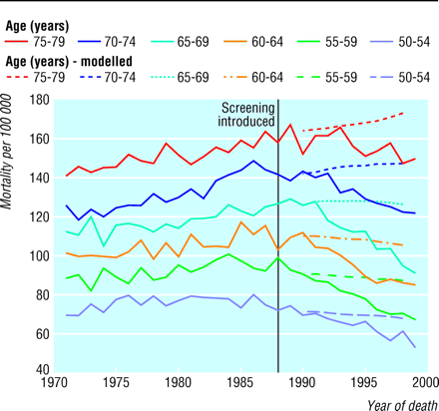

BMJ 2000

Comparison of recorded mortality as compared with predicted (dotted lines).

Slow effect as
- Screening did not cover everybody until 1995
- Those dying in 1990s are mostly those Dx before screening was introduced

Observed fall in mortality rate:
6.3%
due to screening
14.9%
due to Tamoxifen, chemotherapy, more awareness, earlier presentation, etc
21.3%

Deaths prevented by screening estimated at 320

Further reductions hoped for as effect of screening of all women 50-64 since 1995 works through.

Review of the original Swedish RCTs found that al but 2 were flawed in their recruitment, and that the remaining 2 found no effect of screening on breast cancer mortality (Lancet 2000)…but a 2001 Swedish study has shown a large fall in mortality in screened vs non-screened women.

Recent Developments BMJ 16/2/02

BRCA1&2
- Responsible for 5-10% cases
- Carriers have 55-85% risk of developing breast cancer before age 70
  - Reduced by 90% by prophylactic bilateral mastectomy
  - Reduced by 50% with long term Tamoxifen or Oopherectomy
- Screening?
  - Expensive, time consuming, genetic counselling, family trees, blood required from living affected relative

New Drugs…
Aromatase inhibitors stop conversion of Androgens to Oestrogen in eg liver, fat etc
Oestrogen-receptor down regulators

